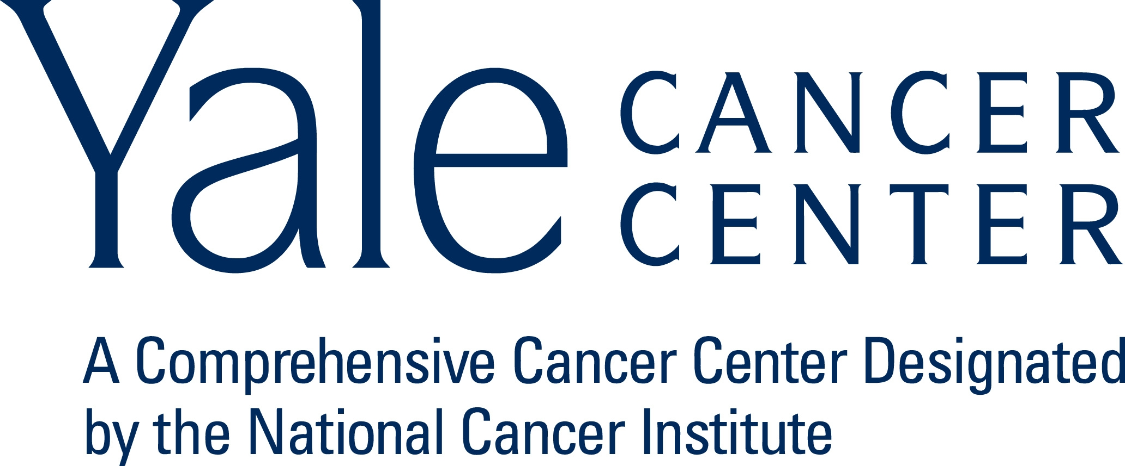
2012 YALE CANCER CENTER RETREAT
Waterview, 215 Roosevelt Ave., Monroe, CT - Grand Ballroom
May 15th, 2012
Retreat: 7:30am-5:00pm; Reception: 5:00-6:30pm

MORNING SESSION
7:30am | Registration and Continental Breakfast
8:00am | Opening Remarks  Thomas Lynch, M.D.
8:10am | Molecular Virology Research Program  Introduction by Program Leader, Daniel DiMaio, M.D., Ph.D.  8:20 Regulation of Epstein-Barr virus late gene expression  Ayman El-Guindy, Ph.D.  8:40 De novo assembly of active hepatitis C virus replication complexes: role of the RNA template  Brett Lindenbach, Ph.D.
9:00am | Cancer Genetics and Genomics Research Program  Introduction by Program Leader, Frank Slack, Ph.D.  9:10 Determining the synergistic effects of combinatorial genetic hits in malignant melanoma  Marcus Bosenberg, M.D., Ph.D.  9:30 Somatic mutations in human cancer: Progress at Yale  Richard Lifton, M.D., Ph.D.
9:50am | Signal Transduction Research Program  Introduction by Program Leader, David Stern, Ph.D.  10:00 Targeting a breast cancer invasion control switch  Anthony Koleske, Ph.D.  10:20 What does milk calcium transport have to do with breast cancer?  John Wysolmerski, M.D.
10:40am | Morning Break
11:10am | Radiobiology and Radiotherapy Research Program  Introduction by Joann Sweasy, Ph.D., on behalf of Program Leader, Peter Glazer, M.D., Ph.D.  11:20 A nuclear envelope bridging complex influences DNA repair  Megan King, Ph.D.  11:40 Can we image EGFR addiction?  Joseph Contessa, M.D., Ph.D.
12:00pm | Director’s Overview  Thomas Lynch, M.D.
12:50pm-1:50pm | Lunch - served downstairs in Garden Room  Shared Resource posters on display in Garden Room  Biostatistics, Cesium 137 Irradiator, Clinical Trials Office, Flow Cytometry, Rapid Case Ascertainment, Yale Center for Genome Analysis, Yale Center for Therapeutic Discovery (Center for Molecular Discovery), Yale Pathology Tissue Services
2012 YCC Retreat Agenda, cont.
AFTERNOON SESSION
1:50pm | Cancer Immunology Research Program  Introduction by Co-Program Leaders, Warren Shlomchik, M.D. and Lieping Cheng, M.D., Ph.D.  2:00 Pluripotency genes as targets for cancer prevention and treatment  Kavita Dhodapkar, M.B.B.S.  2:20 Role of a chitinase-like protein BRP-39/YKL-40 in inflammation and lung cancer  Chun Geun Lee, M.D., Ph.D., M.Sc
2:40pm | Cancer Prevention and Control Research Program  Introduction by Co-Program Leaders, Melinda Irwin, Ph.D, M.P.H. and Yhong Zhu, Ph.D.  2:50 Integrative analysis of cancer genomic data  Shuangge (Steven) Ma, Ph.D.  3:10 Breast Cancer Disparities- the big picture  Beth Jones, Ph.D., M.P.H.
3:30pm | Afternoon Break
4:00pm | Developmental Therapeutics Research Program  Introduction by Co-Program Leaders, Karen Anderson, Ph.D. and Roy Herbst, M.D., Ph.D.  4:10 Understanding and overcoming acquired resistance to targeted therapies in lung cancer  Scott Gettinger, M.D.  4:30 Defining the need and focal points for next generation proteomics in oncology  Andrew Phillips, Ph.D.
4:50pm | Closing Remarks  Thomas Lynch, M.D.
5:00-6:30 | Reception  Please join us for cocktails and hors’ devours in the Grand Ballroom

