Dear Colleagues:

We are pleased to accept nominations for the 4th annual “Ruth McCorkle Oncology Advanced Practice Provider” award. This annual recognition from Yale Cancer Center/Smilow Cancer Hospital will be presented at the YCC Conclave on Monday, November 23, 2015.
Please consider nominating yourself or a colleague for this award. It is a unique opportunity to recognize the contributions of our Nurse Practitioner and Physician assistant colleagues who contribute so much to oncology patient care.
We have enclosed an attached nomination form for your convenience. Nominations will be evaluated and the recipient selected by the YCC/Smilow Leadership. Please submit no later than Friday, October 30, 2015.

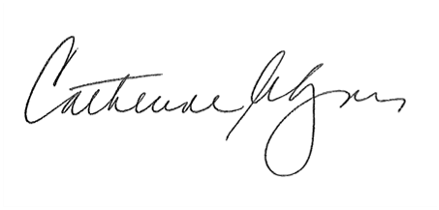
Sincerely,
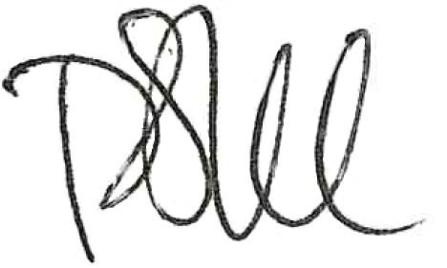

Peter Schulam, MD Catherine A. Lyons RN MS
Interim Director, Yale Cancer Center Executive Director
Physician in Chief, Smilow Cancer Hospital Patient Care Services, Smilow Cancer Hospital

Nomination
Ruth McCorkle Oncology Advanced Practice Provider Award
2015

Nominee: ______________________________________
Your role: ______________________________________

Supporting statement:

Please return nomination to:
Catherine Lyons, RN MS Catherine.Lyons@ynhh.org

